Lab 2: RC Circuits

Session b

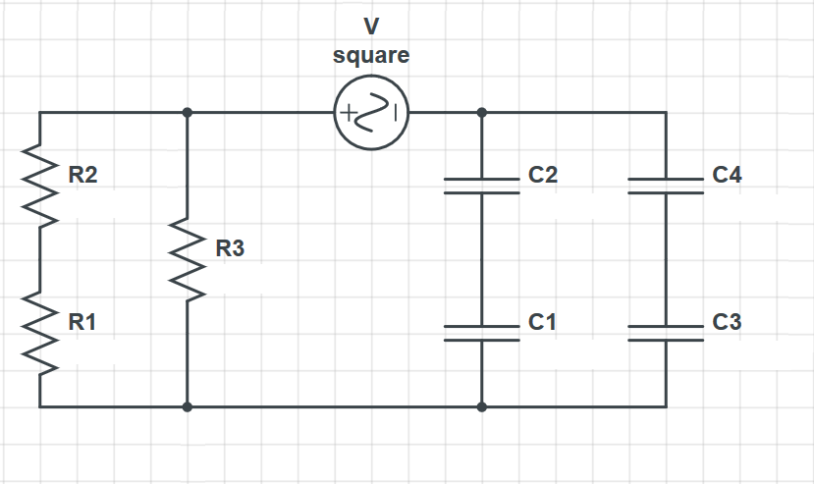

|  |  |
| --- | --- |
| Component | Value |
| $$R1$$ | $$100Ω$$ |
| $$R2$$ | $$200Ω$$ |
| $$R3$$ | $$500Ω$$ |
| $$C1$$ | $100μ$ F |
| $$C2$$ | $100μ$ F |
| $$C3$$ | $50μ$ F |
| $$C4$$ | $50μ$ F |

Desired time constant:

$τ=14.0$ ms

Lab 2: RC Circuits

Session b



|  |  |
| --- | --- |
| Component | Value |
| $$R1$$ | $$200Ω$$ |
| $$R2$$ | $$200Ω$$ |
| $$R3$$ | $$500Ω$$ |
| $$C1$$ | $$50μF$$ |
| $$C2$$ | $$50μF$$ |
| $$C3$$ | $50μ$ F |
| $$C4$$ | $50μ$ F |

Desired time constant:

$τ=11.0$ ms

Lab 2: RC Circuits

Session b



|  |  |
| --- | --- |
| Component | Value |
| $$R1$$ | $$500Ω$$ |
| $$R2$$ | $$500Ω$$ |
| $$R3$$ | $$200Ω$$ |
| $$C1$$ | $$100μF$$ |
| $$C2$$ | $50μ$ F |
| $$C3$$ | $50μ$ F |
| $$C4$$ | $$50μF$$ |

Desired time constant:

$τ=9.7$ ms

Lab 2: RC Circuits

Session b



|  |  |
| --- | --- |
| Component | Value |
|  |  |
|  |  |
|  |  |
|  | F |
|  |  |
|  | F |
|  |  |

Desired time constant:

ms